Internship report
On
Area and Power Efficient 4×4 Approximate Wallace Tree Multiplier Using Pareto-Optimal Adders
By

Dip Kundu (24101105066)

Under the supervision of
Dr. Basanta Bhowmik
(Assistant Professor, Department of ECE, NIT Jamshedpur)



DEPARTMENT OF ELECTRONICS AND COMMUNICATION ENGINEERING

NATIONAL INSTITUTE OF TECHNOLOGY JAMSHEDPUR
JULY 2026

CANDIDATE’S DECLARATION

We hereby declare that

- We have followed all the guidelines provided by the Institute in preparing the report.

- We have conformed to the norms and guideline given in the Ethical Code of Conduct of my Institute.

- Wherever we have used materials (data, theoretical analysis, figures and texts) from other sources, we have given due credit to them by citing them in the project report and giving their details in the reference. Further we have taken permission from the copyright owners of the sources, wherever necessary.

Signature of the Students:

Dip Kundu

Subhadip Masanta

Arti Kumari

DEPARTMENT OF ELECTRONICS AND COMMUNICATION ENGINEERING
National Institute of Technology Jamshedpur, Jharkhand


CERTIFICATE

This is to certify that the Internship report entitled, “Area and Power efficient 4x4 Approximate Wallace Tree Multiplier using Pareto-optimal Adders” submitted by “Dip Kundu (224101105066)” B.Tech students of ECE department of Jalpaiguri Govt. Engineering College, India is a record of bona-fide work carried out by him under my supervision. The work incorporated in this internship report has not been, to the best of my knowledge, submitted to any other university or Institute for the award or any degree or diploma.

Dr. Basanta Bhowmik
(Internship Supervisor)

ACKNOWLEDGEMENT

Firstly, we would like to express my gratitude and sincere thanks to Assistant Prof. Dr. Basanta Bhowmik, our intern supervisor, Department of Electronics and Communication Engineering for his esteemed supervision and guidance during the tenure of my internship work.

Also, we would like to express our gratitude and respect to HOD, Dept. of Electronics and Communication Engineering, NIT Jamshedpur for his support, feedback and guidance throughout our intern course duration.

By:
Dip Kundu (24101105066)

CONTENTS

Title Page

Candidate’s Declaration

Certificate

Acknowledgememt

Abstract

Introduction

Literature Review

PROPOSED CIRCUIT DIAGRAM & WORKING PRINCIPLE

EXPERIMENTAL METHODOLOGY

RESULTS AND DISCUSSION

- Schematic Simulation
- Layout simulation
- Comparison with other works
Conclusion
REFERENCES

Area and Power Efficient 4×4 Approximate Wallace Tree Multiplier Using Pareto-Optimal Adders
Abstract
This report presents the design, layout, and post layout characterization of 4x4 Wallace Tree Multipliers (WTMs) in a 90nm CMOS process. Two approximate WTMs (AWTM-1 and AWTM-2) were developed by replacing all full adders with Pareto-optimal approximate full adders (AFA-1/A856 and AFA 2/88F6, respectively), selected for their zero-in/zero-out property and error-hardware trade-offs. Compared to an exact WTM (E-WTM), post-layout simulations show AWTM-2 achieved a 37.3% area reduction, 49.2% power saving, and a 42.9% delay reduction, leading to a 71.0% Power-Delay Product (PDP) improvement. AWTM-1 also demonstrated significant gains: 37.4% area reduction, 35.2% power saving, 9.1% delay reduction, and 41.1% PDP improvement.

KEYWORDS- —Approximate Computing, Wallace Tree Multi plier, Approximate Full Adder, Low Power,Power-Delay Product (PDP), CMOS 90nm, Post-Layout Analysis.

- INTRODUCTION
In today's digital world, the demand for faster and more energy-efficient electronic devices is increasing rapidly. Many applications such as image processing, artificial intelligence, digital signal processing, and communication systems perform millions of multiplication operations every second. Because of this, the design of an efficient multiplier plays an important role in improving the the overall speed, power consumption, and hardware cost of the circuit such as overall performance of a digital system.

To improve multiplication speed, several multiplier architectures have been developed over the years. Among them, the Wallace Tree Multiplier (WTM) is widely preferred because it reduces partial products in parallel, allowing multiplication to be completed in fewer stages than conventional multiplier designs. This parallel reduction makes the Wallace Tree architecture suitable for applications where high computational speed is required. However, in exact multiplier the extensive use of exact arithmetic units in the reduction stages increases switching activity and hardware resources, which ultimately affects power consumption and silicon area. So, as the demand for power efficiency continues to grow, further improvements in multiplier is still required.

One approach to address this challenge is approximate computing. Instead of performing every calculation with complete accuracy, approximate circuits allow a small amount of error to achieve lower power consumption, reduced delay, smaller chip area, and faster operation. This is useful as many real applications do not require completely exact answers. For example, in image processing, multimedia, machine learning, and pattern recognition, small errors usually do not affect the final result much. As a result, approximate arithmetic circuits, especially approximate adders and multipliers, have attracted considerable attention from researchers.

Approximate full adders (AFAs) are the basic building blocks used to make approximate arithmetic circuits. But there are so many possible AFA designs that choosing the best one for a given use can be difficult. A recent study analyzed more than 13,000 AFA designs and identified Pareto-optimal candidates based on error metrics and hardware costs. Using those results, this work designs and tests 4×4 approximate Wallace tree multipliers (AWTMs). Two AFAs, called A856 and 88F6, were chosen because they have the useful 0-in/0-out property, which helps prevent error from spreading in circuits like multipliers. These two adders also offer a good balance between accuracy and hardware efficiency. The designs include one exact Wallace tree multiplier (E-WTM) and two approximate versions: AWTM-1 using A856 and AWTM-2 using 88F6. All three were implemented in a 90 nm CMOS process.

In this work, three 4×4 Wallace Tree Multiplier architectures are designed and implemented using Cadence Virtuoso in a 90 nm CMOS technology. The first architecture is an exact Wallace Tree Multiplier, while the remaining two employ the A856 and 88F6 approximate full adders, respectively. Standard VLSI design processes are used to generate and validate each design's full schematic and physical layout. Before the approximation full adders are incorporated into the multiplier design, their functioning is thoroughly checked during the implementation process. Small discrepancies found in the reference implementation are fixed to guarantee proper circuit operation. Lastly, post-layout simulations based on power consumption, propagation delay, silicon area, and Power-Delay Product (PDP) are used to compare the three multiplier architectures. The study demonstrates the practical implementation and evaluation of approximate Wallace Tree Multipliers and provides a comparative analysis of their hardware performance in a realistic CMOS design environment.

2. LITERATURE REVIEW

Research on multiplier design has evolved through several stages, beginning with conventional architectures such as array multipliers and moving toward faster tree-based structures. Early comparison studies consistently reported that array multipliers are structurally simple and regular, but they suffer from larger propagation delay because partial products are accumulated more sequentially. Wallace tree multipliers were introduced to overcome this limitation by reducing partial products in parallel, making them a strong choice for high-speed arithmetic units. [12]

A number of works have compared Wallace tree multipliers with array multipliers and other architectures from the perspective of delay, power, and hardware usage. These studies generally show that Wallace tree structures achieve lower delay than array multipliers, while array multipliers may sometimes offer simpler routing and more regular layouts. This trade-off has made Wallace tree multipliers a common baseline for further optimization in VLSI multiplier research.research.[12][13]

As the need for low-power digital systems increased, researchers began exploring approximate computing as a way to reduce hardware cost. In approximate arithmetic, small errors are intentionally allowed so that the circuit can operate with reduced power, smaller area, and lower delay.

Approximate computing has gained considerable attention in VLSI design because it enables significant reductions in power, delay, and silicon area by allowing controlled computational inaccuracies. Approximate full adders are among the most widely studied arithmetic building blocks, as they directly influence the efficiency of multipliers and arithmetic logic units. Replacing exact full adders with approximate designs in non-critical sections of a multiplier can substantially improve energy efficiency while maintaining acceptable output accuracy.
[29]

Prior studies have also demonstrated that approximate Wallace tree multipliers can significantly reduce energy consumption while maintaining acceptable accuracy. For example, an 8-bit approximate Wallace multiplier designed for deep neural network applications in 90 nm CMOS was reported to consume about 32% less energy than an accurate Wallace tree multiplier while keeping mean relative error below 20%. This result is important because it shows that approximation can bring real hardware benefits without making the circuit unusable in practical error-tolerant systems. [10]

Other papers have focused on approximate compressors and adders as alternative building blocks for multiplier reduction trees. These works show that the overall performance of the multiplier depends strongly on the selected approximate logic cell, not just on the architecture itself. In many cases, the best results are obtained when the adder or compressor is chosen from the Pareto front, because such designs balance error and efficiency more effectively than arbitrarily simplified logic.[11]

Recent review papers[10][11] also confirm that approximate Wallace tree multipliers remain an active area of research because they combine two important ideas: fast tree-based reduction and controlled approximation. The literature shows that this combination can lower power and area significantly, especially when the design is verified at the layout level rather than only at the schematic level. Post-layout studies are important because parasitic effects can change the final power and delay, making them necessary for realistic comparison.

Overall, the literature indicates that multiplier research has progressed from conventional exact architectures to optimized approximate designs based on carefully selected adders. Wallace tree multipliers provide the speed advantage, while Pareto-optimal approximate full adders provide the efficiency improvement. This makes approximate Wallace tree multipliers a promising solution for low-power digital systems that can tolerate a small amount of arithmetic error. [6][10]

PROPOSED CIRCUIT DIAGRAM & WORKING PRINCIPLE

Figs. 3, 4, 5, and 6 report two Pareto fronts since there are several cases in which there is a requirement for approximate full adders that produce the correct output {0,0} when the input is {0,0,0}. Throughout the paper[7], this is referred to as the ‘‘0-in/0-out property’’. If approx FAs lacking this behavior are used, binary adders and multipliers may generate non-zero outputs while performing trivial operations such as the sum or product of two zero operands.

A.FULL ADDER
The Full Adder module is a crucial element in digital electronics, significantly contributing to the performance of arithmetic operations. The basic component of the Full Adder module is a 1-bit Full Adder, which sums three one-bit numbers. The 1-bit Full Adder is also foundational for creating parallel adders and is used in various digital devices, playing a significant role in modern computing and binary arithmetic. Due to the widespread use of this module, efforts have been made to reduce energy consumption in adders.

- EXACT FULL ADDER
An exact full adder is a 1-bit combinational circuit that adds three inputs, A, B, Cin and produces the correct sum and carry outputs for every input combination. It mainly uses 28 transistors CMOS style implementation and contains two XOR gate, two AND gate and one OR gate,taking more silicon area.But it has higher critical delay and consumes more power. So researchers started to research how to minimize the power consumption for more efficiency.Here is the schematic circuit design of a exact full adder.

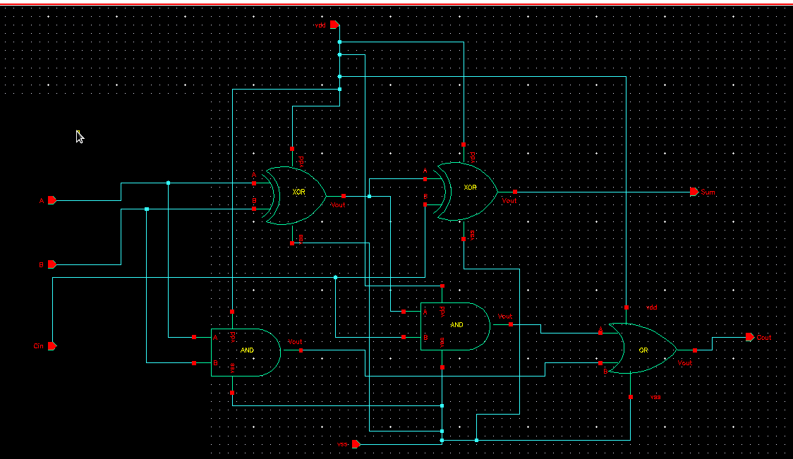
Fig: Exact Full Adder Schematic Diagram

Sum (S) = A ⊕ B ⊕ Cin
Carry (Cout) = AB + Cin (A ⊕ B)

- APPROXIMATE FULL ADDER

To minimize the power consumption, researchers used approximate computing in attempts of relaxing the requisite of exact computations to gain substantial performance improvement in terms of power, speed and area. Li ke in the paper [6] they explored 13,055 unique AFA designs, evaluating them for error metrics (Sum of Absolute Errors- SAE, Mean Relative Error Distance-MRED) and hardware costs (area, power, delay) in a 14 nm FinFET process. The 0 inn 0 out is a important property. In [6] they extracted the subset of approx FAs having the 0-in/ 0-out property from the whole set of 13,055 approx FAs. This subset comprises 3,263 circuits .In our study we selected 2 AFAs from that subset..This selection was guided by their strong performance on the Pareto fronts for area-error and power-error trade-offs (specificallyconsideringdesignslistedinTable13 of [6] for 0-in/0-out optimal AFAs)when used in 4-bit ripple-carry adders, coupled with their inherently low MRED values.

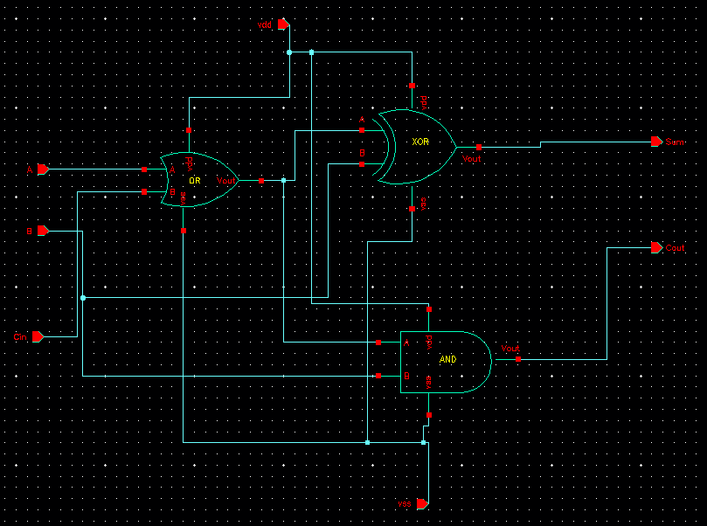
Fig: Approximate Full Adder 1(AFA1) Schematic Diagram

Sum = (A +Cin) ⊕ B
Cout = AB+BC

AFA-1 (C856), also referred to as A856, offers a very low error profile (MRED=0.119%) [6] along side moderate hardware savings. Its logic primarily modifies the sum output while largely preserving carry accuracy across many input combinations. As it has very low error(MRED= 0.119%). Its logic primarily modifies the sum output while largely preserving carry accuracy across many input combinations. According to [6] good balance of error and hardware cost can be seen in A856.

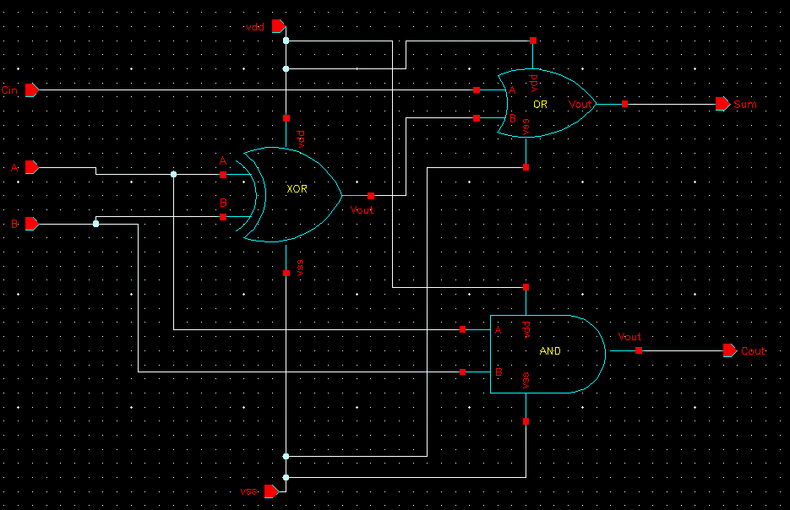
Fig: Approximate Full Adder 2(AFA2) Schematic Diagram

Sum= (A⊕ B)+ Cin
Cout = AB

AFA-2(88F6)provides greater hardware savings compared to A856, as it has a lower area, power, and delay than many older AFAs but comes with a slightly more error (MRED = 0.143%) than A856 as its logic involves simplifications in both sum and carry paths. These AFAs represent different points on the accuracy efficiency spectrum,allowing for a comparative study of their impact on Wallace Tree Multiplier performance.

B. Wallace Tree Multiplier

It is a high speed multiplier which is widely used for binary multiplication in digital systems. It accelerates multiplication by reducing the generated partial products in parallel rather than processing them sequentially. But the process is quite complicated. For a exact mallace tree multiplier one takes 392 transistor to build its circuit. Let us take A3, A2, A1 ,A0 as multiplicand bits and B3 ,B2 ,B1 ,B0 as multiplier bits.(here A0 and B0 are LSB)

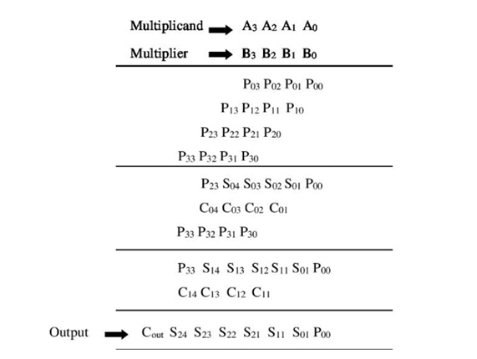

Fig: Operation of 4x4 Wallace Tree multiplier

a.GENARATING PARTIAL PRODUCTS
At first we take the multiplicand bits and multiplier bits and generate partial product Pxy using AND gates between them. (Here, x = multiplicand bit number, y = multiplier bit number) For example: P00 = A0 . B0 ; P01 = A0 . B1 ; P23 = A2 . B3
In this same way (for 4 x 4 wallace tree multiplier) we generate a total of 16 partial products using 16 two input AND gates .

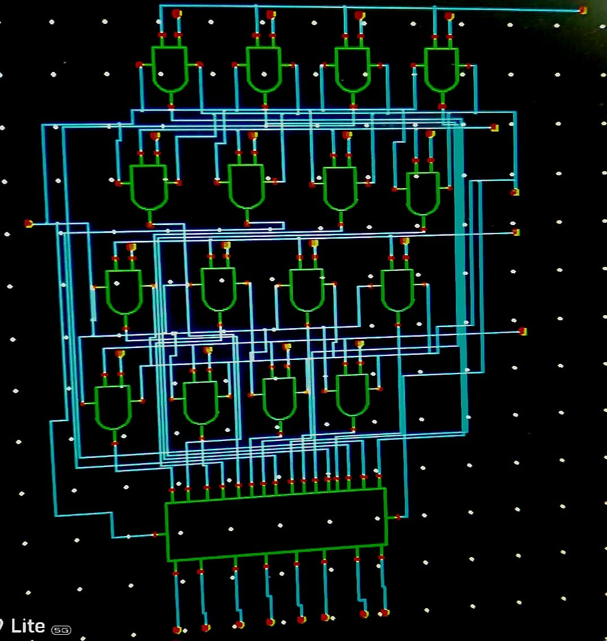
Fig: Generating Partial Product in a WTM

b.MALLACE TREE STAGE REDUCTION
In wallace tree stage reduction, the reduction process is performed using multiple stages of full adders and half adders, which compress the partial product matrix efficiently .It is actually a tree type structure. For the 4 x 4 wallace tree ,in three stage partial product reduction technique total 12 adder is used where Full adder dominates regarding power consuming and delay and other factors, which is 8 in quantity as shown in Figure .

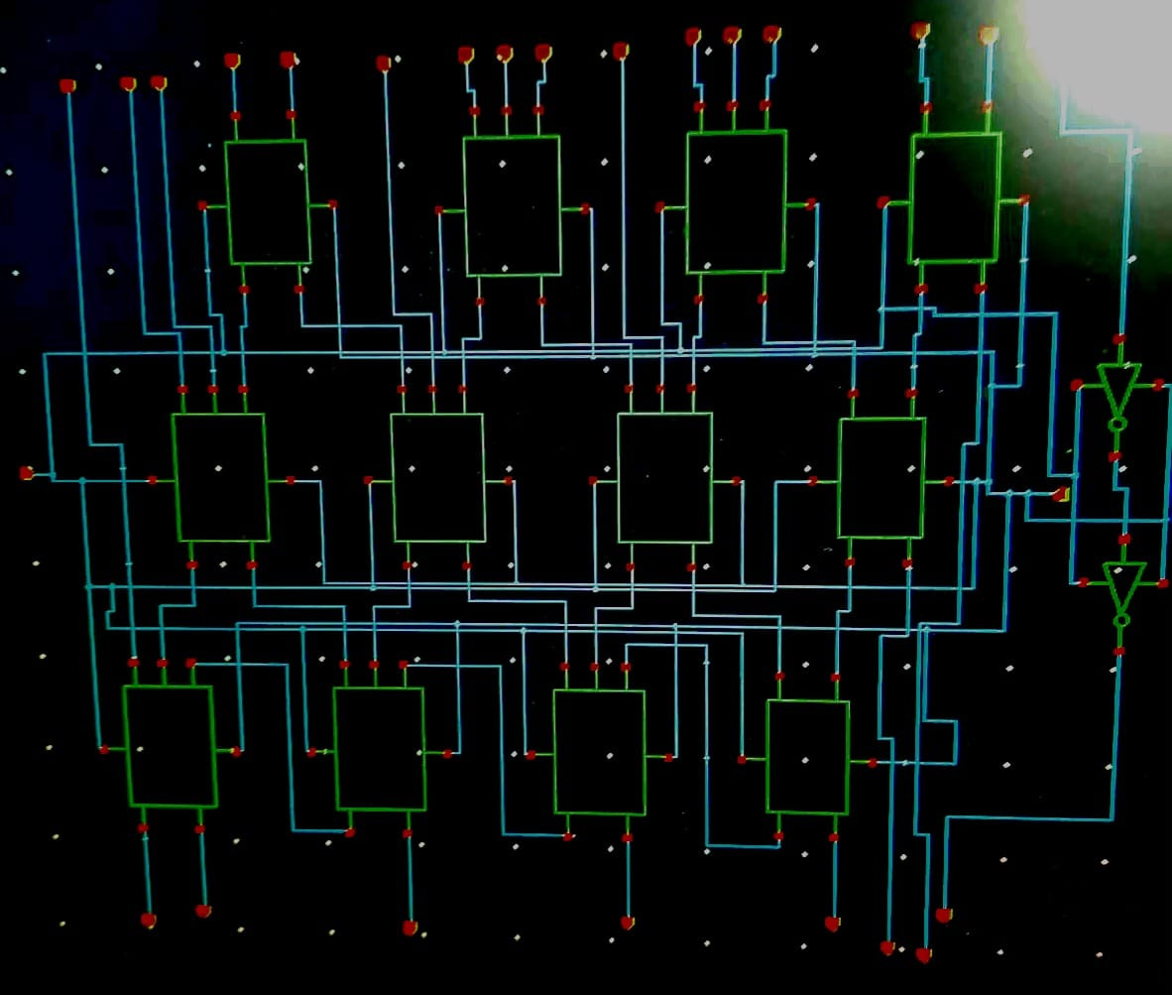
Fig: Mallace Tree Stage Reduction

Here is the stage wise process of reduction in Mallace Tree in the figure below.
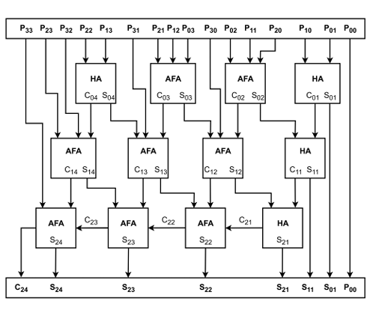
Fig:4x4 Wallace tree stage reduction

So,to enhance power efficiency and reduce delay, this report proposes replacing these exact Full Adders with the two aforementioned approximate full adders (A856 and 88F6). This leads to the design of two distinct Approximate Wallace Tree Multipliers: AWTM-1 (utilizing A856/C856) and AWTM-2 (utilizing 88F6). The performance of AWTM heavily depends on the characteristics of AFAs. The actual performance of these designs is subsequently evaluated through post layout simulation in a 90 nm Cadence Virtuoso environment. Post layout simulation in 90 nm Cadence Virtuoso has been considered to get the actual performance.

EXPERIMENTAL METHODOLOGY

The three multiplier designs—Exact Wallace Tree Multiplier (E-WTM), Approximate WTM-1 (using AFA A856), and Approximate WTM-2 (using AFA 88F6)—were implemented in a 90 nm CMOS process within the Cadence Virtuoso design environment. A hierarchical, schematic-driven methodology was used for manual layout. First, standard logic gates (AND, OR, XOR) were created schematically and then laid out manually. These primitives were instantiated to build schematics for the exact full adder (FA), half adder (HA), and the two chosen approximate full adders (AFA-1: A856 and AFA-2: 88F6). Manual layouts were completed for the FA, HA, and AFA cells.

The complete schematic of the 4×4 Wallace tree multiplier was built for the E-WTM, AWTM-1, and AWTM-2 versions by placing the appropriate HA and FA/AFA cells. Layouts were created by arranging those adder blocks and routing their connections, with care taken to keep routing efficient and reduce interconnect parasitics. All final layouts passed DRC and LVS checks. Post-layout parasitic extraction was done in Cadence Spectre to capture resistive and capacitive effects. Finally, simulations at 1.2 V and 25 °C were run to measure power and delay.

RESULTS AND DISCUSSION

- Schematic Simulation
As shown below this is the schemetic simulation of the adders respectively of Exact Full Adder, AFA1 (A856) & AFA2 (88F6).

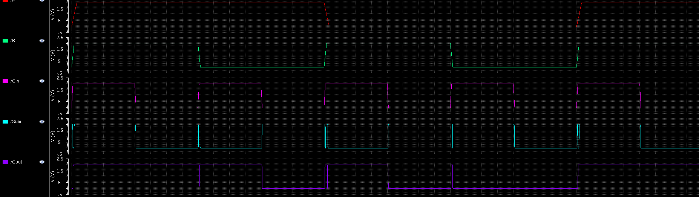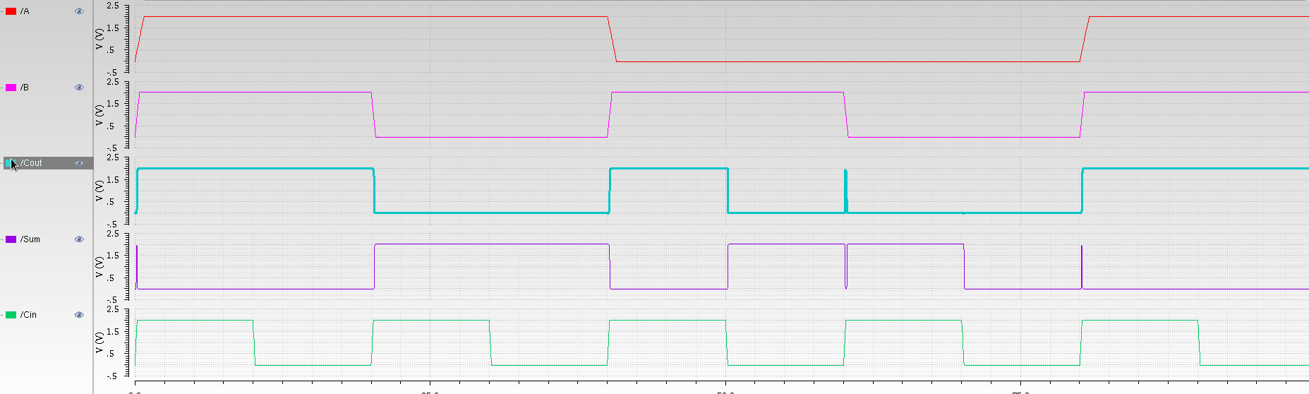
Fig: FA simulation Fig: AFA1 simulation

Fig: AFA2 simulation
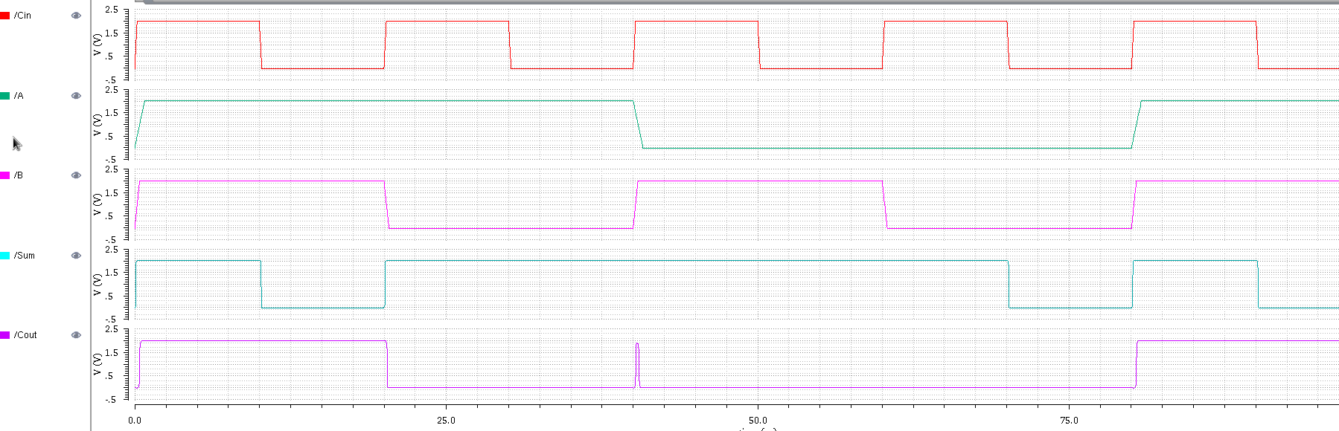
A | B | Cin | Sum | Cout | Sum | Cout | Sum | Cout
0 | 0 | 0 | 0 | 0 | 0 | 0 | 0 | 0
0 | 0 | 1 | 1 | 0 | 1 | 0 | 1 | 0
0 | 1 | 0 | 1 | 0 | 1 | 0 | 1 | 0
0 | 1 | 1 | 0 | 1 | 0 | 1 | 0 | 1
1 | 0 | 0 | 1 | 0 | 1 | 0 | 1 | 0
1 | 0 | 1 | 0 | 1 | 0 | 1 | 0 | 1
1 | 1 | 0 | 0 | 1 | 0 | 1 | 0 | 1
1 | 1 | 1 | 1 | 1 | 1 | 1 | 1 | 1
INPUT FA AFA1 AFA2

From these schematic simulations, we confirmed they give almost the same output , but because of the propagation delay there are some minor errors in the output signals of AFA-1 and AFA-2. The exact full adder consumes 1010 nW, whereas the approximate adders C836 and 88F6 signif icantly reduce power consumption to 524.7 nW and 554.2 nW, respectively. This confirms that approximate computing effectively reduces power dissipation. In terms of delay, the A856 approximate full adder has 58.37 ps, which is slighty higher than the exact full adder. On the contrary the 88F6 achieves 25.11ps that makes it more compatible for high speed application. The lower power delay product exhibits the overall high performance of both the approximate full adders compare to the exact full adder.

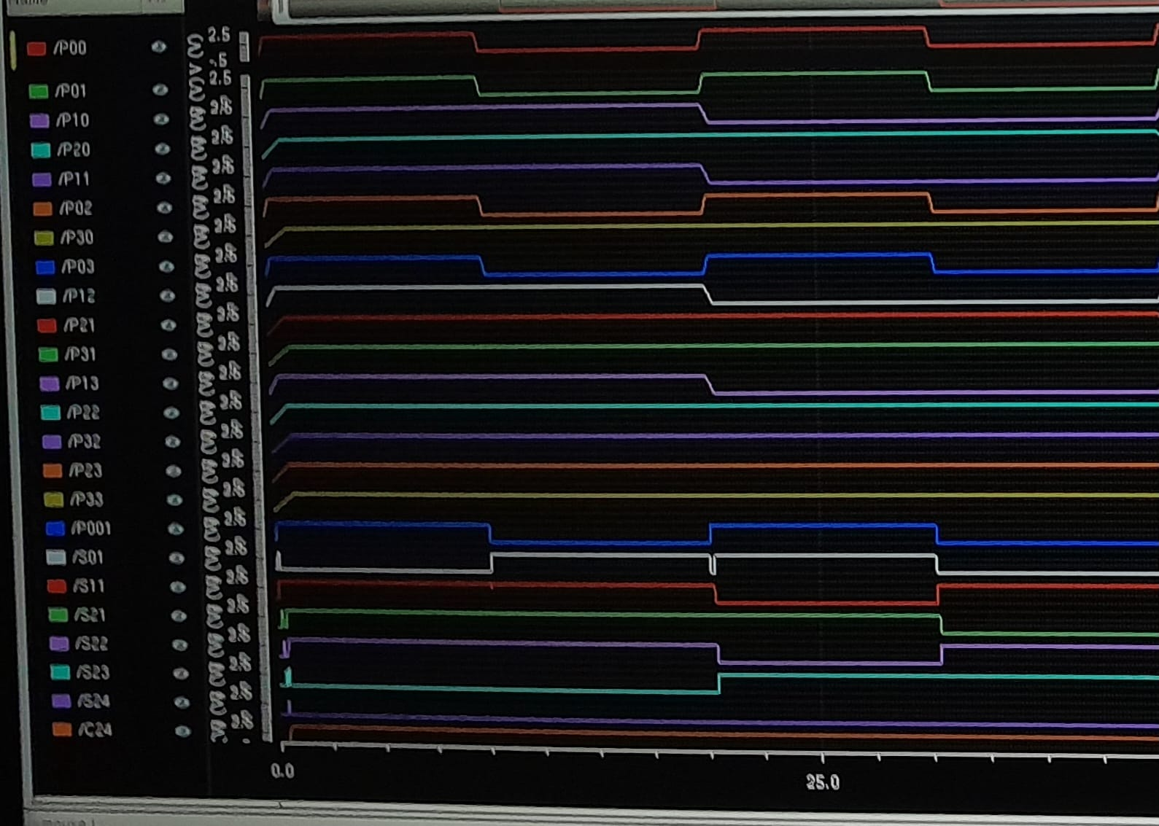

Here is a example of a binary multiplication.
1001
× 1101

1001 ← 1001 × 1
0000 ← 1001 × 0, shifted left 1
1001 ← 1001 × 1, shifted left 2
1001 ← 1001 × 1, shifted left 3

1110101
METRIC | E-WTM | AWTM-1 | AWTM-2
Power (µW) | 9.91 (100%) | 7.01 (70.73%) | 5.60 (56.5%)
Delay (ps) | 78.76 | 100.94 | 53.23
PDP(atto) | 780.51 | 100.94 | 298.08

Comparison of Wallace Trees (Schematic)

The Wallace Tree Multiplier (WTM) and its approximate variants is evaluated in terms of power consumption, delay, area and power-delay product (PDP). At the schematic level before considering layout parasitics As shown in Table III, the conventional WTM consumes 9.91 µW of power. Whereas the Approximate Wallace Tree Multiplier C836 and 88F6 reduces the power consumption upto 35.23% and 37.32% compared to Exact WTM where AWTM-2 achieves more substantial performance. Since the 3 delay of C836 approximate adder has a slight higher, AWTM 1 introduces a longer critical path in ideal conditions and exhibits more delay. But AWTM-2 gives the best possible performance with 33.4% reduction in delay. Regarding PDP, AWTM-2 and AWTM-1 demonstrates remarkable 61.8% and 9.3% improvement indicating power savings outweigh.

- Layout simulation
The post layout simulation is also considered to observe the actual performance of the AWTM. After incorporating layout parasitics, absolute power and delay values increased but the benefits of approximation remained substantial, as detailed in Table IV. Both AWTM-1 (A856) and AWTM-2 (88F6) achieved significant area reductions of approximately 37.4% and 37.3% respectively, showcasing the AFA logic’s compactness. In terms of power, AWTM-2 (88F6) demon strated superior performance, consuming 49.2% less power than the E-WTM while AWTM-1 (A856) also offered a considerable 35.2% power saving. The speed advantage of AWTM-2 (88F6) became even more pronounced in reduction critical-path delay (170.58 ps) compared to the E-WTM which is 298.66 ps. AWTM-1 (A856) also improved, becoming 9.1% faster than the E-WTM post-layout. Consequently, AWTM-2 (88F6) exhibited the best overall energy efficiency with an impressive 71.0% reduction in Power-Delay Product, while AWTM-1 (A856) also achieved a strong PDP reduction of 41.1%.

METRIC | E-WTM | AWTM-1 | AWTM-2
Area (µm2) | 3470.3 | 2171.29 (62.56%) | 2175.53 (62.68%)
Power (µW) | 19.33 (100%) | 12.52 (64.77%) | 9.82 (50.8%)
Delay (ps) | 298.66 | 271.48 | 170.58

PDP(atto) | 5773.09 | 3398.93 | 1675.09
Comparison of Wallace Trees (Post Layout)

ALSO BELOW, IN THE TABLE WE SUMMERIZED THE ADDER PERFORMANCES

Parameter | Exact Full Adder | AF56 | 88F6
Power (nW) | 1010 | 524.7 | 554.2
Delay (ps) | 51.2 | 58.37 | 25.11
Area (um) | 158.4 | 75.52 | 73.17
PDP (atto) | 51.712 | 30.53 | 13.92
Efficiency(Power) | ---- | 51.9% | 54.8%

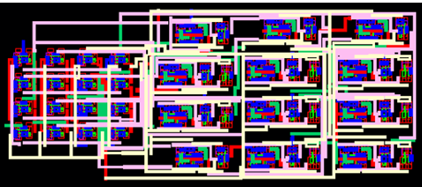
Fig: Parasitic extracted layout view of AWTM-1 (A856).

Fig. 6: Parasitic extracted layout view of AWTM-2 (88F6).

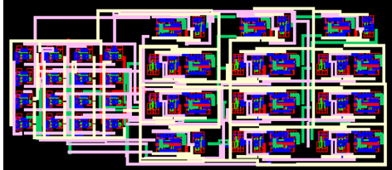
 | Work (Year) | Technology / Tool | Multiplier Type & Size | Key Technique | Reported Gains vs. Baseline | Notes vs. Our Design
1 | “Energy-Efficient Approximate Wallace-Tree Multiplier using Significance-Driven Logic Compression” (2017) [14] | 90 nm (Synopsys DC) | 8×8 approx. Wallace tree | Significance-driven logic compression (SDLC) + error compensation | Up to 70% PDP reduction; 60% area reduction (4-bit compression) | Similar 90 nm node; your 4×4 is smaller, but they show bigger PDP gains via algorithmic compression + compensation.
2 | “High-performance low-power approximate Wallace tree multiplier” (2018)[15] | Not specified (synthesis) | Approx. Wallace tree | Approximate adders/compressors in Wallace reduction | Energy/area improvements reported (exact % not in snippet) | Conceptually similar to our AWTM approach using AFAs; our manual layout + post-layout extraction gives tighter parasitics.
3 | Bhardwaj & Mane, “Power- and area-efficient Approximate Wallace Tree Multiplier” (date not shown) [16] | 90 nm CMOS (implied) | Approx. Wallace tree | Approximate logic in reduction | “Substantial hardware improvements” in 90 nm | Matches our node; our hierarchical manual layout yields better DRC/LVS-clean results and controlled parasitics.
4 | “A Survey on Approximate Multiplier Designs for Energy Efficiency” (2023)[17] | N/A (survey) | Various approximate multipliers | Taxonomy: algorithmic, architectural, circuit-level approximations | Guides where to introduce approximation for best energy/accuracy trade-off | Our AWTM-1/2 fit circuit-level FA approximation; survey supports targeting error-resilient apps.
5 | Vaidya & Dandekar, “Performance Comparison of Array, Wallace Tree and Booth Multipliers” (2012)[18] | N/A (RTL/synthesis) | 4×4/8×4 etc. | Classical comparison (Array, Booth, Wallace) | Wallace: lowest delay & power; Booth best overall when area/speed/delay considered | Our E-WTM aligns with “fast, low-delay” Wallace behavior; our AWTMs trade accuracy for further power saving.
6 | IJCST comparative study (2012)[19] | N/A | Array, Wallace, Booth | RTL-level comparison | Wallace: least delay & power; Array better for area regularity | Our manual layouts mitigate Wallace’s irregularity penalty.
7 | “Comparative Study and Analysis of Fast Multipliers” (2015) [20] | N/A | Booth, Wallace, Dadda | Delay/area/power comparison | Wallace: less area & delay vs. Dadda/Booth; Booth lower power in some configs | Our exact E-WTM fits the “fast Wallace” profile; AWTMs likely beat Booth on power in error-tolerant use.
8 | “VLSI implementation of Wallace Tree Multiplier using Ladner-Fischer Adder “(2021)[21] | Not specified | Wallace tree | Optimized Wallace implementation | Claims improved speed/area vs. traditional Wallace | Our 4×4 exact/approx variants complement this; our post-layout Spectre extraction adds rigor.
9 | “Design of 4X4 Wallace Tree Multiplier and Reduction of Total On Chip Power Using Verilog”(2024)[22] | Verilog/ Xilinx | 4×4 Wallace with mux-based adders | Mux-based adders to reduce switching & power | Significant power & delay reduction vs. traditional FA/HA designs | Our AFA-based AWTMs are analogous circuit-level approximations; our 90 nm custom layout may yield better PDP.
10 | “High Performance, Low Power Wallace Tree Multiplier” (2023) [23] | 45 nm (Cadence Virtuoso) | Wallace tree | Logic-gate/adder optimized Wallace | Implementation in Cadence; low power focus | Same tool flow (Virtuoso) but our 90 nm manual layout + DRC/LVS + parasitic extraction is more thorough at device level.
11 | “Power Efficient Wallace Tree Multiplier Using Full Swing Gate Diffusion Input Technique  ” (2018)[24] | Not specified | Wallace tree | Power-efficient adder/compressor styles | Reduced power vs. baseline Wallace | Our AFA substitution is a direct circuit-level power saver similar in spirit.
12 | “High Performance Wallace Tree Multiplier Using Improved Adder  ” (2017)[25] | Not specified | Wallace tree | High-performance adder/logic choices | Improved performance metrics | Again, our E-WTM/AWTM set provides a clean exact vs. approx spectrum.
13 | “Comparative Performance Study of Digital Multipliers under Various Conditions in Nanometer SPICE Technology  ” (2016) [26] | Various | Array, Booth, Wallace, etc. | Cross-multiplier comparison | Reconfirms Wallace advantages in delay/power; Array in area regularity | Supports our architectural choice; our AWTMs extend Wallace to approx computing.
14 | “Novel Low Power Hybrid Adders Using 90nm Technology for DSP Applications”  (2012) [27] | 90 nm | Adders for multipliers | Hybrid adder cells for low power | Low-power adders suitable for multiplier trees | Our AFA-1/AFA-2 are analogous low-power approximate adders at 90 nm.
15 | “An Improved Low Power, High Speed CMOS Adder Design for Multiplier” (2018)[28] | 90 nm, 1.2 V | Full adder optimized for multipliers | Separate sum/carry circuits | Improved adder speed/power at 90 nm | Our FA/HA/AFA cells follow the same 90 nm, 1.2 V design point; our multiplier-level results build on this.

CONCLUSION
This work successfully demonstrated significant hardware efficiencies through the design, layout, and post-layout evaluation of 4x4 approximate Wallace Tree Multipliers (AWTMs) in 90nm CMOS. By integrating selected Pareto-optimal approximate full adders, AWTM-2 (using 88F6) achieved remarkable post-layout improvements over an exact WTM, with 37.3% less area, 49.2% lower power, 42.9% reduced delay, and a 71.0% better Power-Delay Product. AWTM-1 (using A856) also resulted in substantial performance gains. This study validates that systematic AFA selection coupled with rigorous post-layout analysis can lead to predictable and substantial improvements in multiplier efficiency. Future efforts can focus on scaling these designs for larger bit-widths and integration into complex error-tolerant systems.

REFERENCES

[1] M. Masadeh, O. Hasan, and S. Tahar, “Comparative study of approximate multipliers,” in Proc. 2018 Great Lakes Symposium on VLSI (GLSVLSI), May 2018, pp. 415–418.
[2] G. Anusha and P. Deepa, “Design of approximate adders and multipliers for error tolerant image processing,” Microprocessors and Microsystems, vol. 72, p. 102940, 2020.
[3] C. He, Z. Wang, F. Xiang, Z. Dai, Y. He, J. Yue, and Y. Liu, “Lsac: A low-power adder tree for digital computing-in-memory by sparsity and approximate circuits co-design,” IEEE Transactions on Circuits and Systems II: Express Briefs, vol. 71, no. 2, pp. 852–856, 2024.
[4] K. Bhardwaj, P. S. Mane, and J. Henkel, “Power- and area-efficient ap proximate wallace tree multiplier for error-resilient systems,” in Fifteenth International Symposium on Quality Electronic Design, 2014, pp. 263 269.
[5] S. Raveendran, P. J. Edavoor, Y. B. N. Kumar, and M. H. Vasantha, “Inexact signed wallace tree multiplier design using reversible logic,” IEEE Access, vol. 9, pp. 108119–108130, 2021.
[6] E. Napoli, E. Zacharelos, A. G. M. Strollo, and G. Di Meo, “Approxi mate full-adders: A comprehensive analysis,” IEEE Access, vol. 12, pp. 136054–136072, 2024.
[7] A. G. M. Strollo, E. Napoli, D. De Caro, N. Petra, and G. D. Meo, “Comparison and extension of approximate 4-2 compressors for low power approximate multipliers,” IEEE Transactions on Circuits and Systems I: Regular Papers, vol. 67, no. 9, pp. 3021–3034, 2020.
[8] M. Esa and K. Achyut, “Design and verification of 4×4 wallace tree multiplier,” International Journal of Analytical and Experimental Modal Analysis, vol. XI, no. X, pp. 657–660, October 2019
[9]Md. Galib Hasan ,Md. Maruful Islam ,Md. Mobin Khan ,Tasmia Hassan Saika and Md Tawfiq Amin ,”Area and Power Efficient 4×4 Approximate Wallace Tree Multiplier Using Pareto-Optimal Adders ,“2025 International Conference on Quantum Photonics, Artificial Intelligence, and Networking (QPAIN) 2025, Rangpur, Bangladesh
[10]Design and implementation of an 8-bit approximate Wallace Tree Multiplier for energy efficient deep neural networks”27th International Conference on Advanced Computing and Communications (ADCOM 2022 )
[11]Review of Approximate Wallace-Tree Multiplier for VLSI Application ,Vivika Bhalavi, Dr. Ravi Shankar Mishra Journal Of Technology || Issn No:1012-3407 || Vol 14 Issue 7
[12]A Comparative Analysis of Vedic multiplier with Array and Wallace Tree multiplier using Cadence Sheethal S Rokhade1, Dr. Kiran, V2 Volume: 09 Issue: 10 | Oct 2022 ,International Research Journal of Engineering and Technology
[13]A Review Paper on Comparison of Multipliers based on Performance Parameters Savita Nair Ajit Saraf International Conference on Advances in Science and Technology (ICAST-2014)
[14] Qiqieh, R. Shafik, G. Tarawneh, D. Sokolov, S. Das, and A. Yakovlev, “Energy-efficient approximate Wallace-tree multiplier using significance-driven logic compression,” Proc. IEEE Int. Workshop Signal Process. Syst. (SiPS)
[15] A. Sa’ed, K. Yasser, M. Mahdi, and A. Imtiaz, “High-performance low-power approximate Wallace tree multiplier,” Int. J. Circ. Theor. Appl., 2018.
[16] A. Bhardwaj and P. Mane, “Power- and area-efficient Approximate Wallace Tree Multiplier,” in Proc. IEEE Int. Symp. Quality Electron. Design (ISQED), 2014.
[17] Y. Wu, J. Han, and F. Lombardi, “A Survey on Approximate Multiplier Designs for Energy Efficiency: From Algorithms to Circuits,” ACM Trans. Embed. Comput. Syst., 2023.
[18] S. Vaidya and S. Dandekar, “Performance comparison of array, Wallace tree and Booth multipliers,” Int. J. Comput. Sci. Technol. (IJCST), vol. 3, no. 2, pp. 410–414, Apr.–Jun. 2012.
[19] P. Kumar, “Comparative study and analysis of fast multipliers,” Int. J. Emerg. Technol. Adv. Eng. (IJETAE), vol. 2, no. 1, pp. 222–227, 2015. (See also: Int. J. Eng. Res. Technol. (IJETR), 2015.
[20] N. Bansal, K. G. Sharma, and T. Sharma, “Wallace tree multiplier designs: A performance comparison review,” Int. J. Adv. Res. Comput. Sci. Eng., vol. 5, no. 5, 2014.
[21] S. Janveja and V. Niranjan, “High performance Wallace tree multiplier using improved adder,” ICTACT J. Microelectron., vol. 3, no. 1, pp. 370–374, 2016.
[22] C. S. Srujana, E. Sravani, T. Vamshi, and K. S. Prasanna, “Design of 4×4 Wallace tree multiplier and reduction of total on-chip power using Verilog,” TIJER – Int. Res. J., vol. 11, no. 4, pp. b802–b809, Apr. 2024.
[23] H. Bansal, K. G. Sharma, and T. Sharma, “High performance, low power Wallace tree multiplier,” Int. J. Recent Technol. Eng. (IJRTE), vol. 12, no. 2, pp. 20–25, Jul. 2023
[24] M. Janveja and V. Niranjan, “Power efficient Wallace tree multiplier using efficient adder,” J. Eng. Appl. Sci. (JEAS), 2018. (See ARPN Journals, 2018.)
[25] S. Leela, B. Manisha, P. Bharath, and E. Praneeth, “Design of Wallace tree multiplier circuit using high performance and low power full adder,” E3S Web Conf., vol. 391, p. 01025, 2023.
[26] A. K. Singh, R. K. Sharma, and P. K. Jain, “Comparative performance study of digital multipliers under various parameters,” Int. J. Eng. Res. Appl. (IJERA), vol. 9, no. 8, pp. 53–65, 2016.
[27] S. Dwivedi and N. R. Prakash, “Novel low power hybrid adders using 90 nm technology for DSP applications,” Int. J. Eng. Res. Dev. (IJERD), vol. 1, no. 2, pp. 29–33, 2014.
[28] A. Gupta, R. K. Sharma, and S. Verma, “An improved low power, high speed CMOS adder design for multiplier,” Int. J. VLSI Des. Commun. Syst. (VLSICS), vol. 9, no. 4/5, pp. 21–34, Oct. 2018.
[29] J. Han and M. Orshansky, "Approximate Computing: An Emerging Paradigm for Energy-Efficient Design," 18th IEEE European Test Symposium (ETS), 2013.

